Sanger Mayor Resigns Amid Racial Tensions, State Investigation
By JOE MOORE • JUN 3, 2015
SHARE
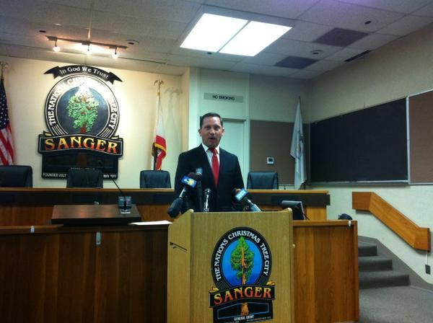 Sanger Mayor Joshua Mitchell announced his resignation Wednesday amid a climate of racial tensions at City Hall and allegations of corruption involving his business interests.
CREDIT JOE MOORE / VALLEY PUBLIC RADIO

Sanger Mayor Joshua Mitchell is stepping down. FM89’s Joe Moore reports it’s the latest move in a city that’s been rocked by turmoil, corruption charges and a state investigation into the mayor’s actions.

Vandalism, arson, and even death threats. Those are just some of the claims made by Sanger Mayor Joshua Mitchell who announced his resignation Wednesday.
Mitchell: "I have suffered quite a bit of ailments, as has my family. Currently I've had to move my wife out of Sanger and to an undisclosed location on the perimeter of Sanger."

But Mitchell who says he can no longer work with the other members of the city council says there’s also another reason he’s leaving office early.
Mitchell: “The amount of racism that is going on at city hall, people being questioned as to their ethnicity.”

Mitchell says he decided to resign after the city council tried to fire city manager Brian Haddix late last year. The reason? Mitchell claims it was over council concerns about the lack of Latinos working at City Hall. He cited a letter from council member Humberto Garza.

Mitchell: "We look at this letter right here. It indicates that there are too many white people working at city hall. Ok. Brian Haddix, at no fault of his own, the fault of his parents, is white."

Mitchell who is also white, credits Haddix with turning around the city’s finances after the recession. Haddix recently left the city on his own to take a similar position in Chowchilla. Mitchell says the city’s economic development direct has also announced his resignation, and others have similar plans. Council member Garza didn’t respond to Valley Public Radio’s requests for comment on the resignations.

But Mitchell faces problems of his own. He’s currently the subject of an open investigation by the state’s Fair Political Practices Commission, over allegations that his landscaping company did work for a housing developer that benefited from a vote by the council to waive development fees. Mitchell said he’s aware of the investigation but claims there’s no basis to the allegations.

Mitchell was also fined last year by the state for failing to follow campaign finance rules.

© 2015 Valley Public Radio About Listen Contact Staff Schedule Podcasts Privacy FM 89.3 Fresno / FM 89.1 Bakersfield White Ash Broadcasting 3437 W. Shaw Ave #101 Fresno, CA 93711

